Lifting the ‘Vale’ on the Green Green Grass of Home


Cardiff based sports pitch design consultants GEO Turf Consulting Limited take us through the role they played in the recent construction of the new training grounds for the Football Association of Wales.

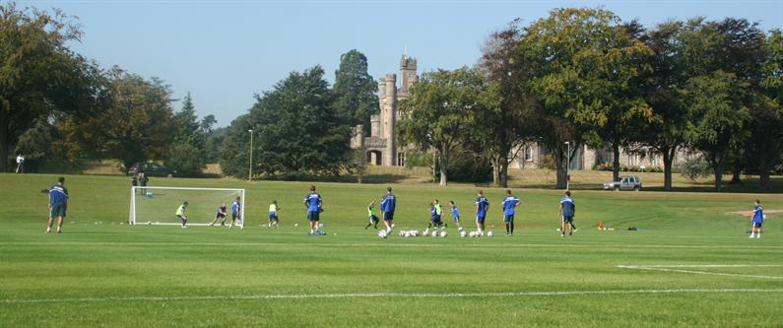

Deep in the heart of the Vale of Glamorgan countryside and adjacent to the Vale Hotel, Golf and Spa Resort, lies the 17th century Hensol Castle Conference Centre and its 150 acres of estate grounds. Some of us would perhaps recognize its interior from recent episodes of Dr Who, where it doubled as that of No.10 Downing Streets’. Beautiful as its interior is however, we are more interested for the moment in what has recently gone on outside its walls.

The castle is an impressive structure, but for sometime before its acquisition by Leekes Retail and Leisure Group the grounds in front of the castle had been somewhat underutilized. The Leekes Group also owns the Vale Hotel Golf and Spa Resort, and so had already greatly improved the infrastructure around the site, and it’s grounds staff have considerable expertise in grounds maintenance, as witnessed by the quality of it’s two golf courses. Therefore the new owners saw an opportunity to improve and develop some of the grounds of the castle into additional sports facilities. The first phase commenced in the summer of 2006 with the construction of 15,000m² of much needed good quality natural turf training facilities for the Football Association of Wales.

“It was never going to be easy to develop a potentially politically and environmentally sensitive site” said Mr Gerald Leeke. “The local planning authority obviously wanted a sympathetic development in keeping with these beautiful surroundings, and of course this was exactly what we wanted too”. Thankfully, experienced assistance in this type of development was available from Cardiff based GEO Turf Consulting Limited who specialize in the design and engineering of natural turf sports facilities.

Led by Jonathan Smith, himself an expert with over 20 years experience in implementing both small and large schemes, with recent projects including the Exeter Chiefs Rugby Club, Swansea City Football Club training pitches and advising The Highways Agency on the development of Wetherby Racecourse. GEO Turf Consulting was the natural choice for the project, especially as their main offices are in the local Cardiff area.

“Our work normally involves the development of natural turf facilities on both green and Brownfield sites. We assist clients from the early feasibility and planning consent stages, through to detailed design, managing contracts, and then on to completion.

We also of course help manage the all-important first years maintenance following handover to the client. Unfortunately, we also sometimes have to act as fire fighters to rescue projects that have all too often suffered from a combination of poor design, construction and supervision. Thankfully the Hensol Castle project was not one of these. It did however provide a number of interesting challenges for GEO Turf. “There were one or two acts of God which kept us and White Horse Contractors on their toes, but thankfully we are all extremely proud of the finished product”.

So what do natural turf pitch consultants do when brought in on such a project? The first step in the design process was the implementation of a detailed three-dimensional topographic survey. In parallel to this a full survey of the site was performed, which included an assessment of the existing geology, topsoil and underground services.

“We are often instructed to help with liaison with the powers that be in the early stages of many of our projects. Mr Leeke had already established a good relationship with the local council and in spring 2006 he asked GEO Turf to prepare the detailed Planning Consent design drawings. These included three-dimensional computer generated ground models, plus sections of the existing and proposed ground profiles. A few minor issues and concerns were soon resolved, and so permission was granted to commence construction of the high quality training pitches with a state of the art fully automatic irrigation system. Soon afterwards the design was issued for competitive tender to a select list of proven specialist natural turf pitch contractors. Following the tender evaluation process the contract was awarded to White Horse Contractors Ltd of Abingdon.

As most of you may be aware, a major cost in any development involving earthworks is the transportation of construction materials including soils, sands and drainage aggregates, to the site. Paying a high price to bring in material, which is then left over and needs to be moved at further cost is an unacceptable expense. It also makes the effective use of existing on site materials very important. To optimize the use of existing materials and to minimize the purchase of new ones, GEO Turf make use of the latest three dimensional ground modeling software, in conjunction with the detailed topographic survey, to compute the exact quantities of construction materials required. The software also produces a detailed output on where subsoil needs to be cut from and where it should be used as in-fill.

All major earth moving was performed using large back-acting excavators and bulldozers fitted with compaction equipment. However, armed with the computer 3D model, the finer cutting and filling, to produce a precisely graded plateau for construction, was achieved using a laser controlled grader.

“Firstly a rotating laser is set up to the required gradient and level, and then a grader moves across the site using the laser as its datum point. Where material needs to be removed the laser controlled blade planes off a layer which is then deposited where levels are low. The final result is an accurately laser graded cut and filled formation. In this case we incorporated a 1 in 100 gradient across the area to aid drainage, but kept the line of play level.

The natural drainage on the site was poor and the near surface geology was comprised of glacial till which was a mixture of clay, gravel and pockets of running sand. The problems presented by the variable, and in places, wet ground conditions were exacerbated by the fact that the land was traversed with deep Victorian land drains installed at 6.0m centres. In addition, following the earthworks, there remained a long and steep slope running down from a road to the upper edge of the training area. While the training teams favour this, as they sprint up the slope to develop strength, in the wet, it directs a considerable volume of surface water runoff over the site. To address these problems a deep trench was dug at the base of the slope and a 300mm diameter perforated drainage pipe laid. This primary drain would act as a cut off drain to protect the work in progress and later, the finished product.

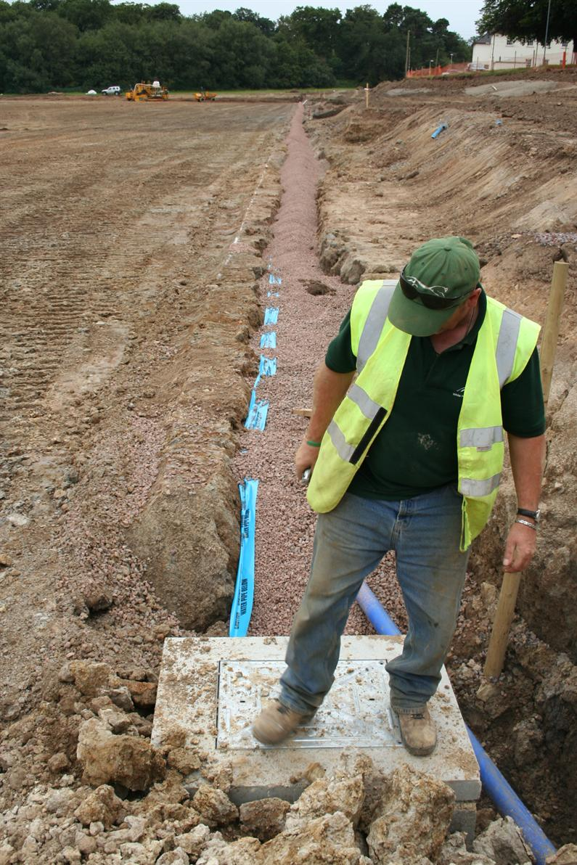

Welshman Steve Evans of White Horse Contractors very much at home while inspecting his 300mm dia cutoff drain.

Following the installation of the cutoff drain and the laser grading of the formation 150mm diameter carrier drains were installed around the perimeter of the area. From these drains 300mm deep lateral drains were cut to into the formation at 5.0m centers. These were then in-filled with approved 5 mm - 10 mm drainage aggregate. A separator geotextile was then placed between the drains and 150mm depth of grit was installed to form a drainage carpet across the graded formation.
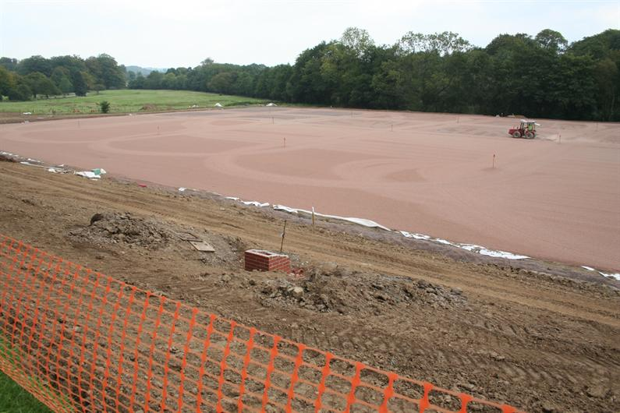

Grading of the grit drainage layer

A benefit of the grit layer is that if required the drainage properties of the profile can be quickly improved with verti-draining. The verti-drain will not only help to relieve any compaction present, but it will also form direct drainage channels through the pitch profile into the grit drainage layer. Fertilizer can be brushed into the holes to get the nutrients deep into the profile, and then if required, the holes can be in-filled with an approved medium fine top-dressing sand which will act as a preferential drainage pathway into the grit.

Following the installation of the grit drainage layer a 100mm depth of approved medium fine sand was installed to act as a basal growing medium with good drainage properties. The analysis of the existing topsoil showed a sandy silt loam, containing over 50% silt plus clay. The possibility of utilizing the topsoil in the construction was carefully considered, but the practicalities and the volume of sand required to dilute the fines to a satisfactory level meant that it was decided to import a pre-blended sand/soil mix. The job was given to Tarmac Topsport which produced a blend of Kingsley No1 sand with British Sugar Soil with the resulting uniform mix having a maximum fines content of approximately 15% and a very low stone content.

The benefit of having a relatively high level of fines is that it assists with nutrient and moisture retention. The fines also help to improve surface stability and negate the need for artificial reinforcement, which under certain circumstance may lead to harder surfaces if poorly maintained. We have also found that soil with higher levels of fines tend to be less prone to the Black Layer condition than sandier rootzones. This is because the fines may act as redox buffers, which help to prevent the biological reduction of sulphate to phyto-toxic sulfides.

A possible negative of having higher fines content is the potential for restricted surface drainage when the soil becomes compacted. At the Hensol castle site, to overcome this potential restriction, forced slit drains were installed at 750mm centres along the line of play. These secondary drains are 50mm wide and installed through the soil profile to a depth of 300mm into the grit drainage layer. During installation the slit drains were in-filled with a uniform 2.0mm grit which has a high drainage capacity and flows easily through the installation equipment, even when wet. A small degree of heave is created during the installation of the forced slit drains, but this is removed with the final cultivation and surface sand dressings.

The installation of slit drains during construction results in getting the area into play in a shorter period of time, as it negates the need to disturb the playing surface following grass establishment. Also, due to the extra compression of the soils around the sides of the forced slits, the likelihood of future settlement is reduced. This in turn reduces the need for costly topping up. A benefit of the extra compression placed on the sides of the forced slits may be the reduced risk of future settlement, and the resulting need for costly topping up following construction.

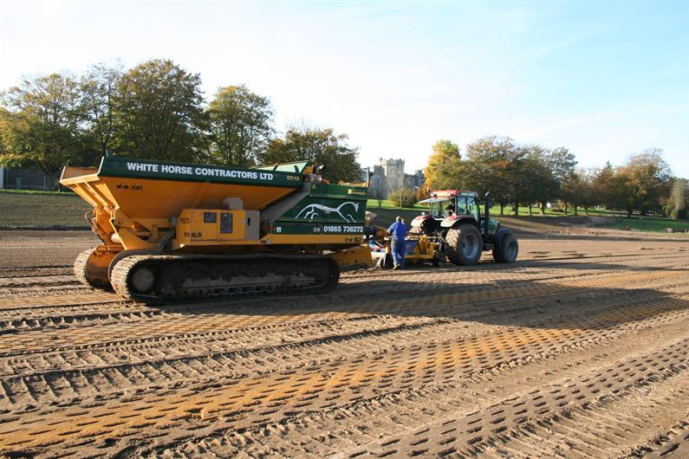

November 2006- Installation of the forced slit drainage system prior to seeding

Following the installation of the slit drains, 10mm depth of medium fine sand was installed over the surface and then the area was seeded with Barenbrug Bar 7. Again, due to tight schedules, the first seeding of the site took place in mid November. As was expected initial establishment was poor, but then came a rather long act of God. Months of solid rain! Although the drainage system was in place, it could not stop the movement of large volumes of surface water runoff during intense rainfall. The problem was exacerbated by the fact that without grass cover fines tended to separate out and cause capping of the pitch surface, reducing surface drainage rates. With little or no root system to anchor the surface, areas of washout occurred together with a large proportion of the seed being simply washed off the surface. A useful tip for people facing the similar problems is to install a line of straw bails at strategic points. This will help to reduce the flow of surface water and prevent scouring. The installation of bails at the toe of newly created embankments can also be useful in preventing fines running off the embankment onto the pitch surface.
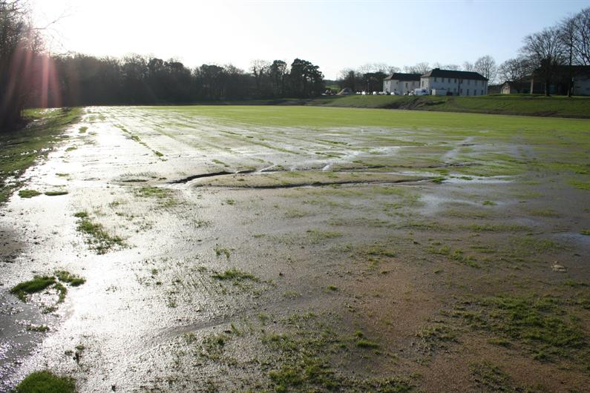

Mid January 2007. Surface in poor condition following two months of intense rainfall.

As soon as the deluge was over the site drained quickly and remedial work started immediately. A rootzone was dressed into to the washed out runoff areas and over-seeding was carried out. Thankfully no more serious deluges took place and the seed germinated to enhance the existing sward. A further 6.0mm dressing of sand took place three times from April to July to ensure the integrity of the slit drains and to improve surface durability and quality of the playing surface. Following this the first verti-draining operation took place in order to get the topsoil into better condition.



Late April 2007 and the good weather is now making a difference to sward density and rooting depth.
As you may remember from the December/January edition of Pitchcare, ecological sustainability in this environmentally aware age is becoming increasingly important. One such step in the right direction for the Hensol Castle site was to use a naturally occurring spring as the water source for irrigation. The spring had in the past been used to supply water to the Hensol Estate and underground storage tanks and pumps were fortunately located close to the development area. It was simply a case of renewing the pumps and then connecting the new ring main into the mains supply pipe, which led to the castle. A total of twenty-six pop-ups were installed around the perimeter of the area and twenty-four within the pitch surface, with the electronic control panel being located in the nearby changing rooms.

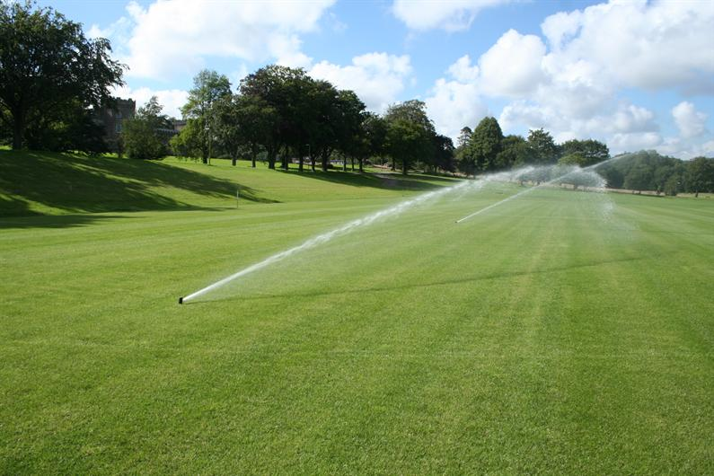

Spring 2007 – Irrigation in full swing
One thing GEO Turf always stipulate when taking on a project is that they will visit the pitches a number of times in the first year to check, and if need be remedy, any problems that may occur. “Over the years we have seen a number of properly constructed pitches which have had the best start in life then suffer following inappropriate maintenance. It is usually not anyone’s fault, but the first year can be a bit of a minefield while the root system and turf density improves.

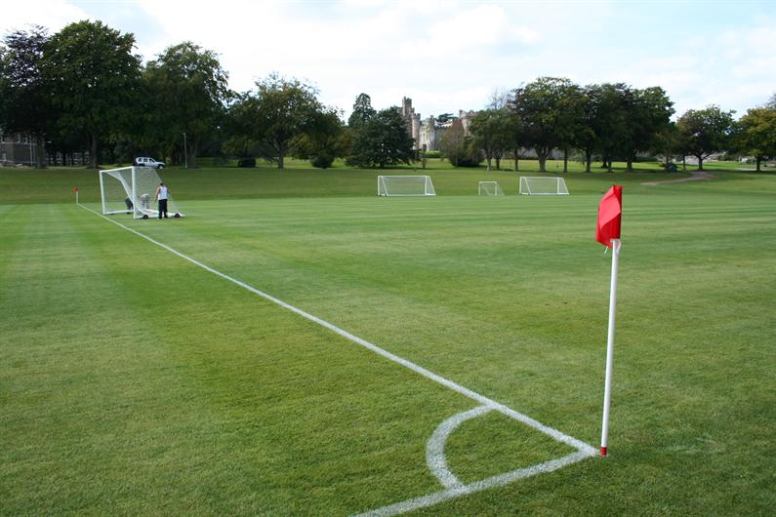

August 2007 – Final preparation of the finished product

The pitches have recently reached full usage and look magnificent. The sward is deeply rooted and is proving very resilient to the training and the matches now taking place on it. But take our word for it, if you are lucky enough to visit The Vale Resort, please feel free to inspect the pitches. On our last visit the Welsh football squad had just finished using the area in preparation for their European Championship Qualifiers and Cardiff City FC were in full swing. They told us the pitches were ideal for their requirements. Even the goalies, seen here with Jonathan Smith (the short one), were happy, although they requested a supersoft padded area around the goalmouth so as to have more comfortable landings! You can please some of the people…….”

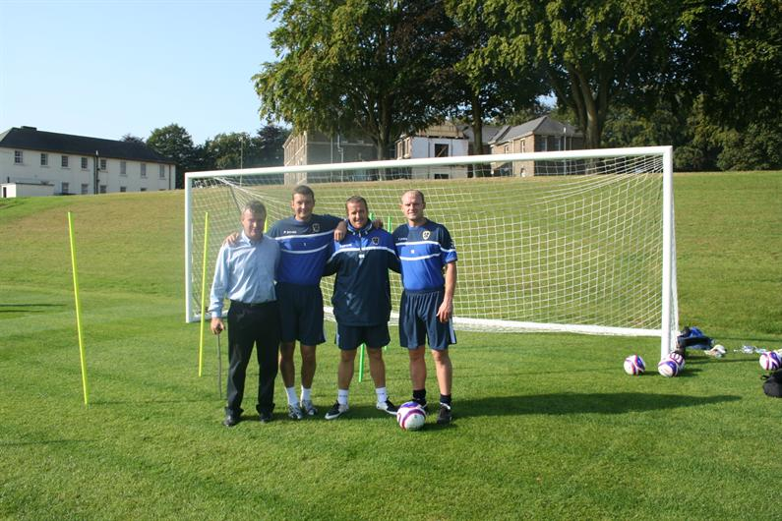

September 2007 – Cardiff City Football Club taking a well earned rest from training.

GEO Turf Consulting Limited can be contacted on 02920 531335 or visit their website at www.geo-turf.com

White Horse Contractors Limited can be contacted on 01865 736272 or visit their website at www.whitehorsecontractors.co.uk

The Vale Golf and Spa Resort can be contacted on 01443 667800 or visit their website at www.vale-hotel.com

Article by Ed Keane BSc (Hons) BEng (Hons) of GEO Turf Consulting Limited.

